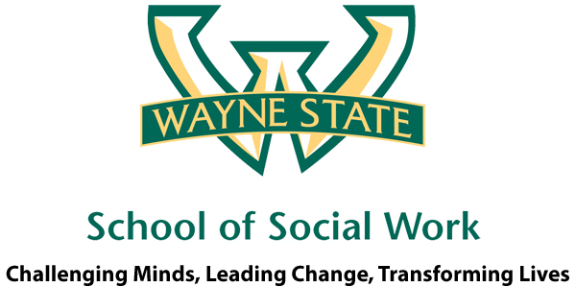

Information retrieved from http://www.whitehouseconferenceonaging.gov/issues/index.html

Inside This Issue

1 Did You Know?

2 SW Happenings at Wayne

3 Careers in Aging: Case Manager

4 Myths on Aging

5 Next Meeting

This year marks the 50th anniversary of Medicare, Medicaid, and the Older Americans Act, as well as the 80th anniversary of Social Security. These topics will be some of the issues discussed at the 2015 White House Conference on Aging. The 2015 White House Conference on Aging is an opportunity to look ahead to the issues that will help shape the landscape for older Americans for the next decade. As we listen to aging leaders and older Americans, some of the common themes we hear include the following:

**Financial security** in retirement provides essential peace of mind for older Americans, but requires attention during our working lives to ensure that we are well prepared for retirement.

**Long-term services and supports** remain a priority. Older Americans overwhelmingly prefer to remain independent in the community as they age. They need supports to do so, including a caregiver network and well-supported workforce.

**Healthy aging** will be all the more important as baby boomers age. As medical advances progress, the opportunities for older Americans to maintain their health and vitality should progress as well.

**Financial exploitation, abuse, and neglect** are all areas of vulnerability for older Americans. The Elder Justice Act was enacted as part of the Affordable Care Act, and we need to realize its vision of protecting seniors from scam artists and others seeking to take advantage of them.

As in the past, The 2015 White House Conference on Aging should prove to be an enlightening and educational event. The date and location of the event has not yet been scheduled but be sure to stay up-to-date on the details at:

*http://www.whitehouseconferenceonaging.gov/issues/index.html*

**Words of Wisdom from Across the Ages**

***Marilyn Q. Bryant-Corbitt***

Are you a student, faculty or staff member?  Doesn't matter, we all can benefit by learning and practicing some self-care exercises.  That's right, at least 5 minutes alone where you can ask yourself how you are doing.  Only then can you develop an early warning system for yourself.

1. What's on your plate?  Take stock of your work/home load.
2. Find some time for yourself every day, even if it’s just sitting in the sunshine or moonlight.
3. Learn to delegate where and when it’s appropriate.
4. Learn to say no … because you are naturally giving to others, you may always be the "go to" person.
5. Exercise, walk, read, sit on the front porch, or commune with nature.

Next month, I'm passing on an article that hit home with me. I think you might see something of yourselves in this one as well.  Cheer up, and eat an ice cream cone ... sitting down!

# Did You Know?

February, 2015

Issue 2

From Practice to Policy

Promoting Older Adults

“The 2015 White House Conference on Aging allows us to highlight the contributions of older adults today, and to shape the landscape of aging for the decade to come.”

A Wayne State University Learning Community

The Thompson Home, 3645 Cass Avenue

Detroit, MI 48243

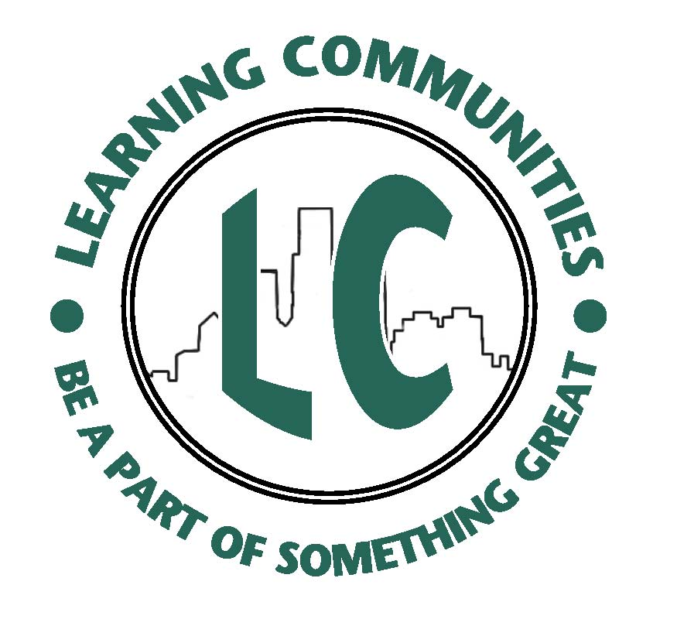

# Geriatric Case Manager: Job Description, Salary, and Outlook

A geriatric case manager is responsible for assisting elderly clients with the administrative side of health care issues, advising and often acting as a liaison between the client, their families, health care providers and government agencies. Geriatric case managers must understand the comprehensive needs of senior clients, and perform care assessments to identify individual health care needs. They must then devise a comprehensive plan for that client, working with health care professionals, service providers and government agencies to put that plan into action. Once a plan is put into place, a geriatric case manager continues to maintain that plan by scheduling in-home, outpatient or hospitalization services, assisting clients with legal issues and offering transitional assistance for clients seeking assisted living or nursing home care.

The mean annual salary for geriatric case managers in May 2012 was $82,240 for nursing care facilities, with home health care services paying an annual salary of $88,670 and outpatient care centers paying $94,720 (*www.bls.gov*). A December 2013 job search on *Payscale.com* revealed salaries for geriatric case managers with 1-4 years of experience ranging between $28,383 and $74,378, with earnings increasing to between $36,096 and $81,686 with 5-9 years of experience.

Employment for medical and health service managers is growing faster than the national average, according to the BLS, and is expected to continue a steady growth through 2020. Approximately 13% of all workers in 2010 worked for nursing care facilities and home health care services.

Information retrieved from www.education-portal.com

The Promoting Older Adults Learning Community will be holding a poster contest during the Careers in Aging Week, April 7-11, 2015. Students interested in careers in aging are asked to make an e-poster on the topic of their choice and present it to Wayne State faculty and the learning community students at the April 9th meeting. Members of the social work staff will be judging the contest and prizes will be awarded for the top 2 posters. Join us at the February 26th meeting to find out more about how you can learn a new skill, network with faculty, meet other students interested in gerontology, and be an advocate for the population that will need much more attention in the upcoming decades. For more information regarding the next Promoting Older Adults Learning Community meeting, please see the last page of this newsletter.

# Careers in Aging

By Cindy Kluz

# SW Happenings at Wayne …

# Promoting Older Adults Learning Community Poster Contest

Careers in Aging Week

April 7-11, 2015

Poster Contest

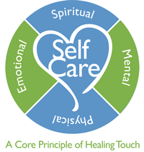

**Next Meeting**

When: February 26, 2015

Time: 3:30 p.m. – 5:00 p.m.

Place: Thompson Home

Room 33

3645 Cass Avenue

Detroit, MI 48243

For questions or to contact us, please email:

Dr. Tam Perry: teperry@wayne.edu

Cindy Kluz: fb0556@wayne.edu

We hope to see you there!

## Myth #1: Elderly people become more religious as they age.

Members of the present older generation did not become more religious as they aged, but grew up in a time when there was more formal religious training given to children. Their lives were often started on a more religious path that continued throughout their lives. It seems the difference is generational rather than age-related.

## Myth #2: The majority of elderly persons are socially isolated and lonely.

When asked about loneliness, only 12 percent of the elderly felt loneliness was a problem. Family and friends largely determine whether or not an elderly person is lonely and rarely is an elderly person totally abandoned in our society.

## Myth #3: The elderly are slow to learn, less intelligent and more forgetful.

There are differences in learning rates and styles between age groups, but it would be incorrect to say older people have difficulty learning. Preschoolers learn differently from children in grade school and they learn differently from high school students. We do not assume these differences are wrong. How older adults learn is different from younger learners, but that does not mean they cannot understand new information.

For more information, visit: ***www.oregon.gov****/.../****Myths****%20and%20****Stereotypes****%20of%20****Aging****.pdf*

F

# Myths on Aging

Information retrieved from www.oregon.gov